Programming document for complex:

**Day 1 (1/16/2023)**

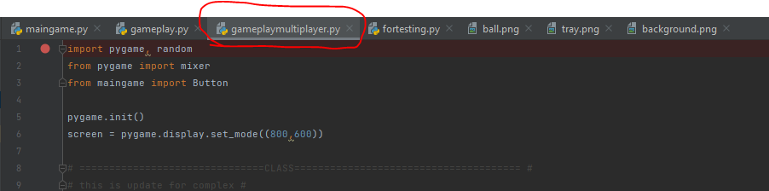

Figure 1:

The “gameplay.py” has changed to “gameplaymultiplayer.py”. The “gameplaysingleplayer.py” will be add soon.

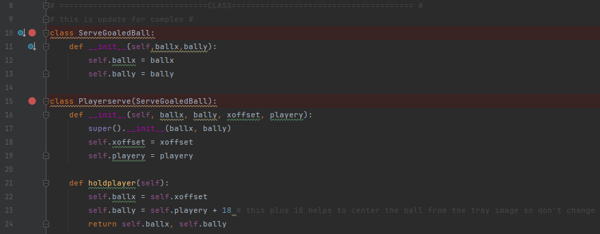

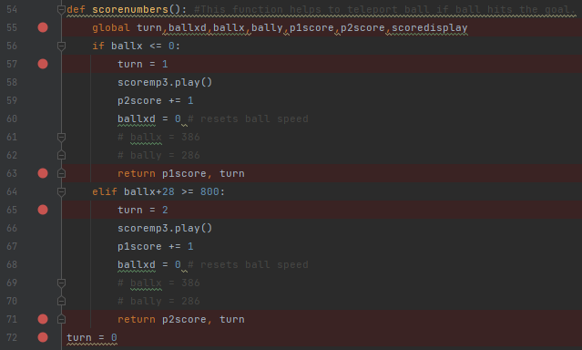

Figure 2.1:

Added classes, variable “turn”, and modify “scorenumber()” to function the player serving ball

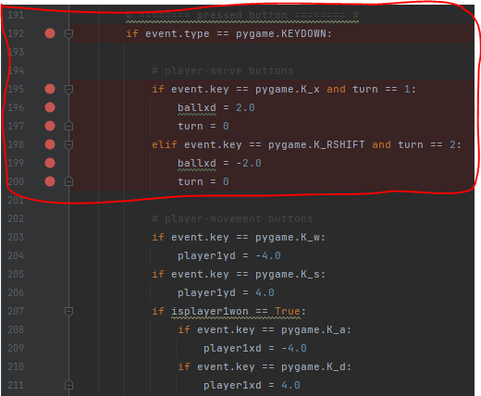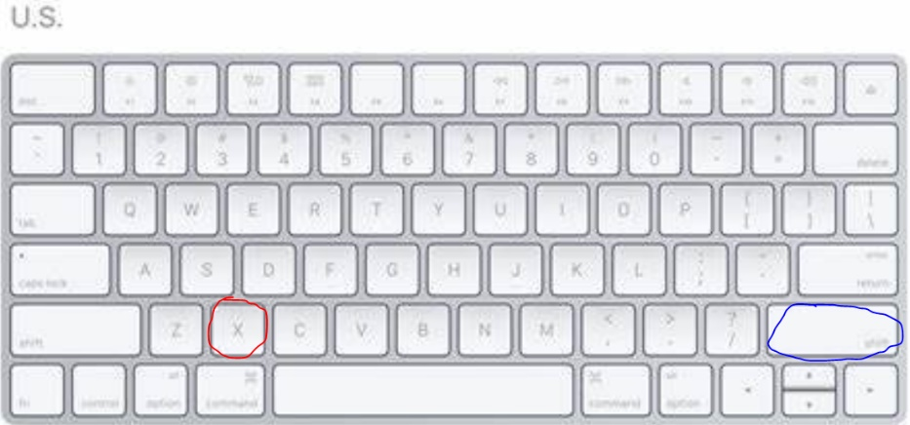

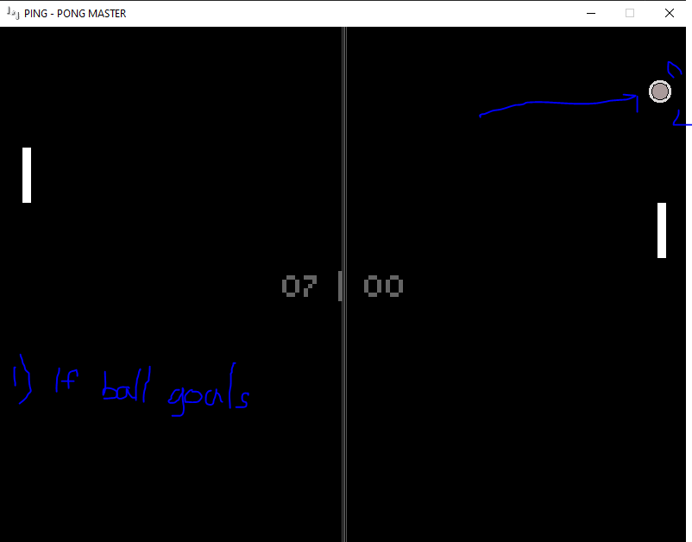

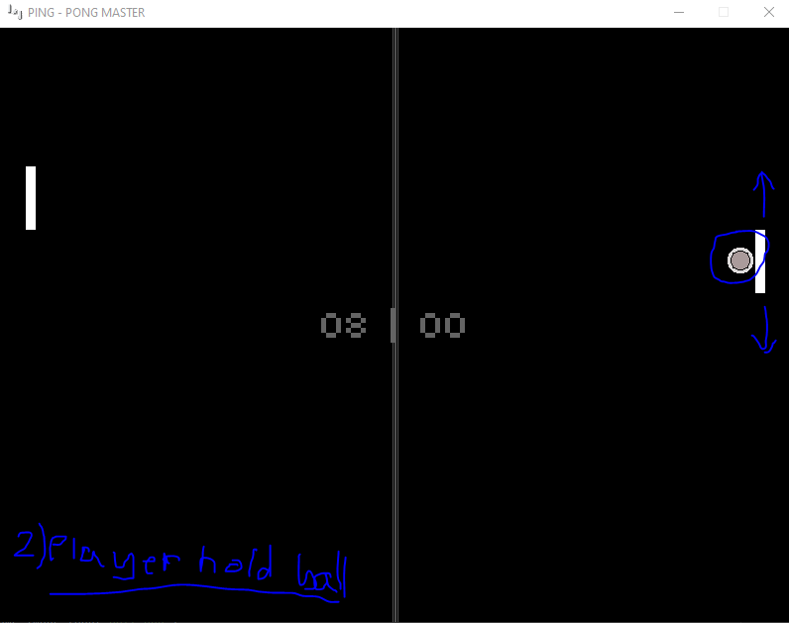

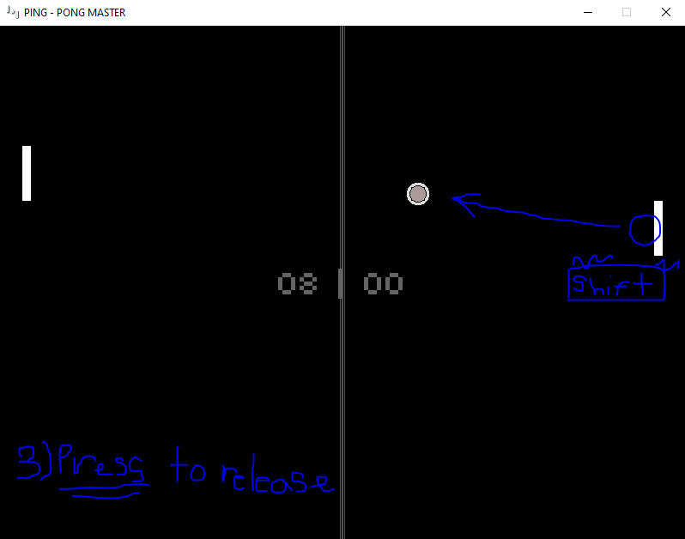

Figure 2.2:

Added buttons to release the serve ball for each player. “X” for player1; “Right Shift” for player2.

-if ball hit goals, the ball will teleport to the player, the ball is stuck to the player’s y coordinate.

-if pressed the release button, the player serves the ball.

**Day 2 (1/17/2023)**

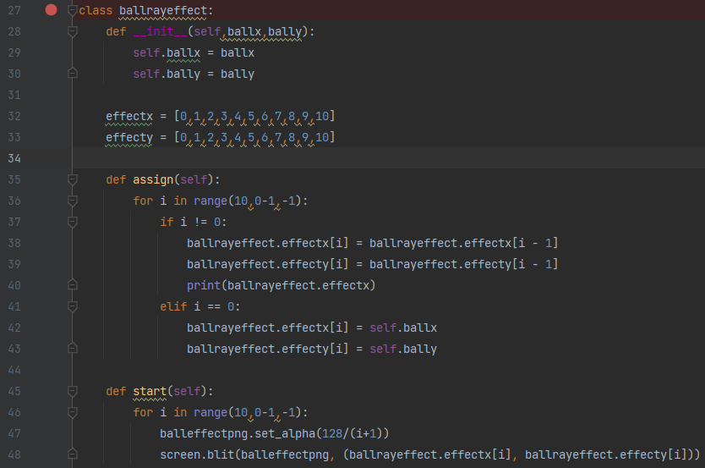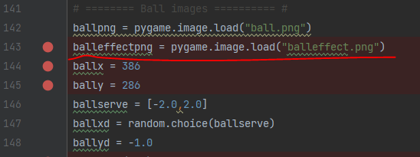

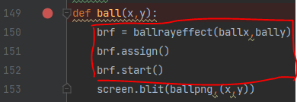 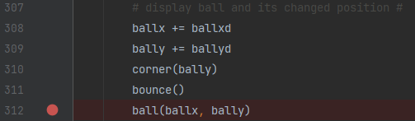

Figure 3.1:

Added classes and function “ball” with new image “balleffect.png” to create an trail effect of the ball.

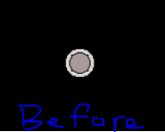 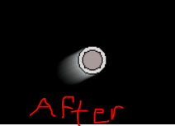

Figure 3.2:

The Trail effect of the ball.